1. **System’s Flowchart**

**Case Study**

**in**

**Furniture Information System**

SUBJECT:INTEGRATIVE PROGRAMMING AND TECHNOLOGY

**Created by:**

Ariane A. Gerona

BSIT-2A

**Submitted to:**

Emannuel Saligue

Instructor

1. **Entity Relationship Diagram**

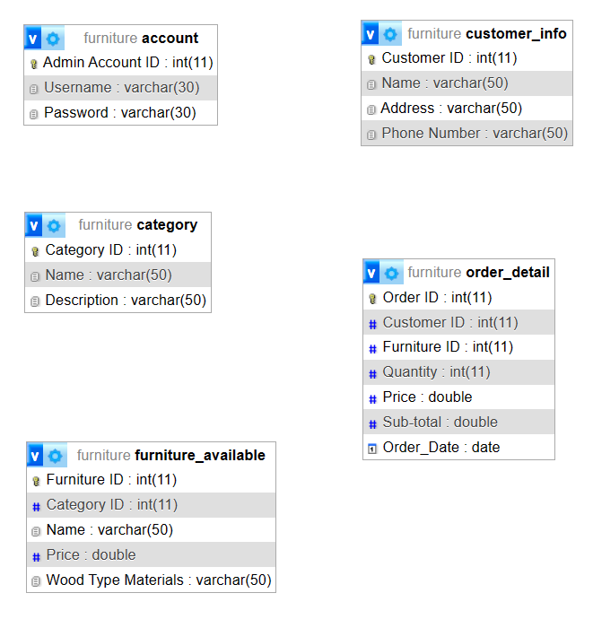

1. **System’s Interface**

**Figure 1: Log In Form**

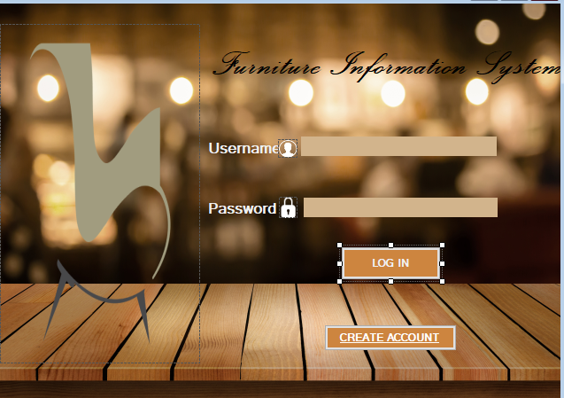

**This is the Login Interface where the Admin can login to his/her account.**

**Figure 2: CreateAccount Form**

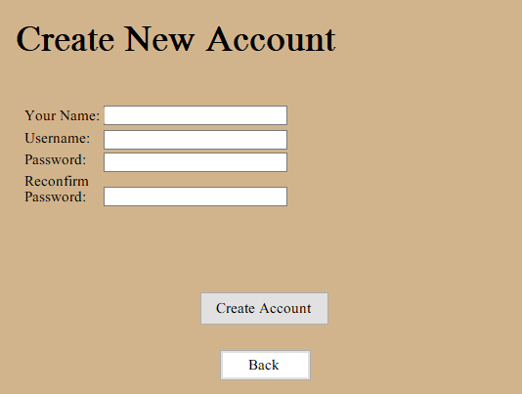

**This is the Create account Interface where you can Create account.**

**Figure 3: Main Menu Form**

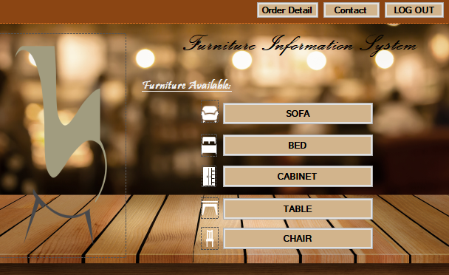

**This is the Main Menu Interface where you can select the product that are displayed and you can click also the order detail, contact and logout.**

**Figure 4: Furniture Available Form**

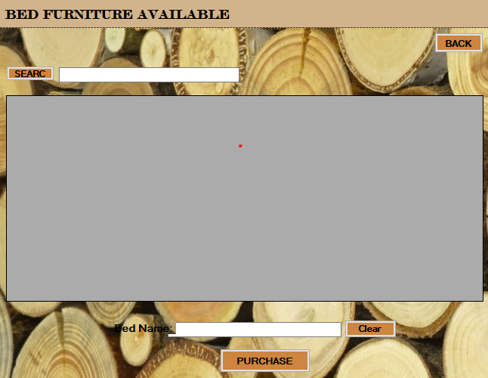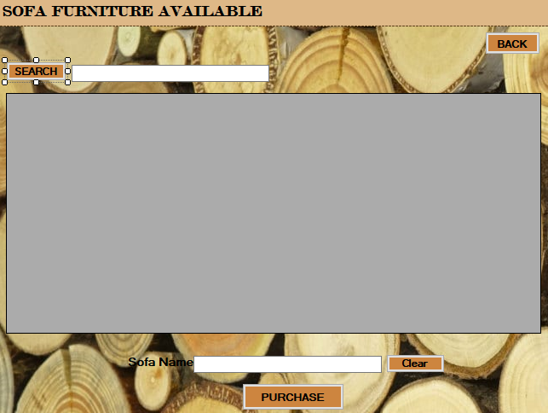

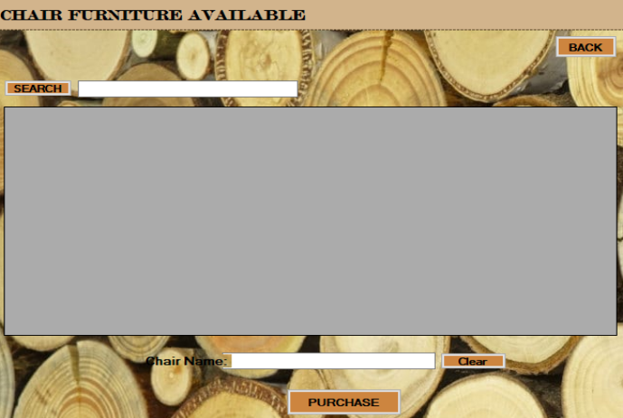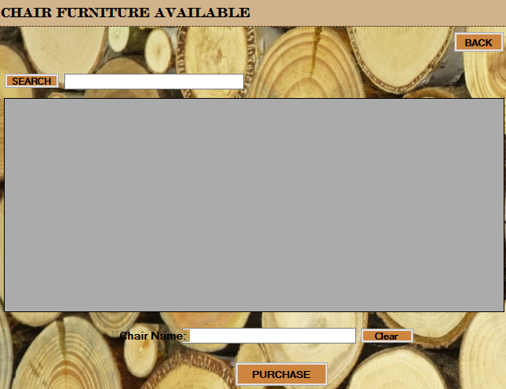

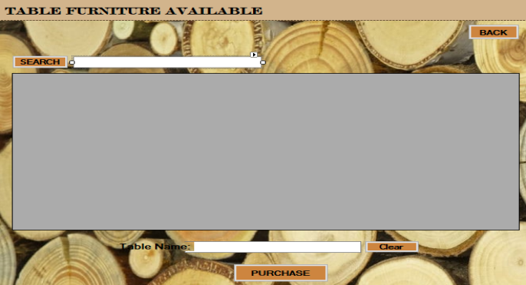

**This is the Furniture Available Interface where you can purchase the furniture you want.**

**Figure 5: Purchase Form**

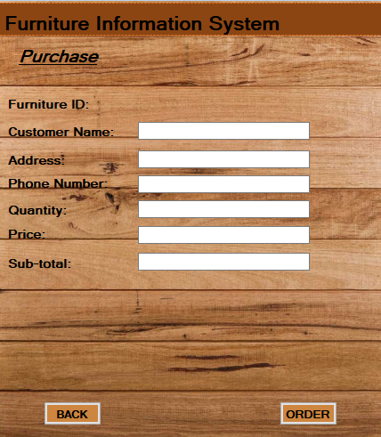

**This is the Purchase Interface where you can order the furniture.**

**Figure 6: View Order Form**

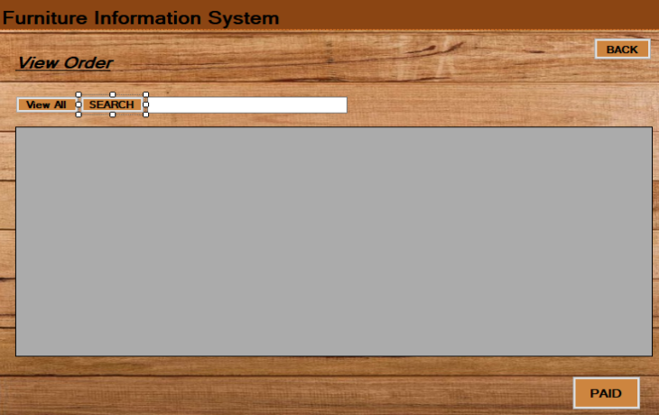

**This is the View Order Form Interface where you view the Order of the customer.**

**Figure 7: Contact Form** 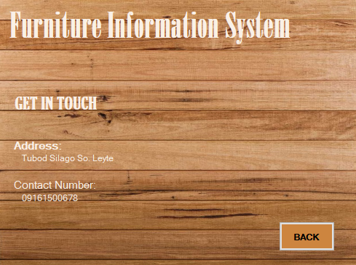

**This is the Contact Form Interface where the customer can see the contact information.**

1. **API Endpoint**

**1. Create Account**

Create a new customer account in the furniture store.

Endpoint: /create-account

HTTP Method: POST

Parameters:

username (required): The username for the new account.

password (required): The password for the new account.

**2. Login**

Authenticate and login to the furniture store with an existing customer account.

Endpoint: /login

HTTP Method: POST

Parameters:

username (required): The username of the admin account.

password (required): The password of the admin account.

**3. Get Furniture Data**

Retrieve furniture data from the store.

Endpoint: /furniture

HTTP Method: GET

Parameters:

displayData (required): The type of furniture data to display. Possible values: "MaxID", "ORDERDETAIL", "ord".

**4. Search Furniture**

Search for furniture in the store based on specific criteria.

Endpoint: /search

HTTP Method: GET

Parameters:

displayData (required): The type of furniture data to display. Possible values: "BED", "beds", "CABINET", "cabinets", "CHAIR", "chairs", "order", "SOFA", "Sofas", "TABLE", "Tables".

searchData (required): The search keyword or criteria to filter the furniture data.

**5. Update Furniture Status**

Update the status of an order detail in the furniture store.

Endpoint: /furniture

HTTP Method: PUT

Parameters:

id (required): The ID of the order detail to update.

tableName (required): The name of the table to update. Only "orderdetails" is supported currently.

Status (required): The new status to set for the order detail. Only "Paid" is supported currently.

1. **Insert Furniture**

Inserts new data into the specified table in the database.

Endpoint: POST /furniture

HTTP Method: POST

Parameters:

tableName (string): The name of the table to insert data into. Possible values: "customer_info", "order_detail".